# Home

GUI Guideline

Version 1.0

Developed by Nguyễn Thành Tâm

History

|  |  |  |  |  |  |
| --- | --- | --- | --- | --- | --- |
| **Date** | **Ver.** | **Description** | **Page** | **Written By** | **Mentor** |
| 2022.04.29 | 1.0 | Final Home UI Document | All | TamNT | ThanhPB |
| 2022.03.07 | 0.1 | Home UI Document | All | TamNT | ThanhPB |
|  |  |  |  |  |  |

**Table of content**

1. COMMON

1.1. Layout .................................................................................................................................... 4

1.2. Font ....................................................................................................................................... 5

1.3 Back ground............................................................................................................................ 6

1.4. Button Image ......................................................................................................................... 7

2. Home Area 8

2.1. Application Button ............................................................................................................... 9

3. Widget Area 10

3.1. Climate Widget ............................................................................................…………………….. 11

3.2. Media Widget .........................................................................................….……………………… 12

3.3 Widget Button.........................................................................................…………………………. 14

4. Status Bar Area 15

4.1. Back Button..........................................................................................................................16

5. Application Layout 17

### Layout

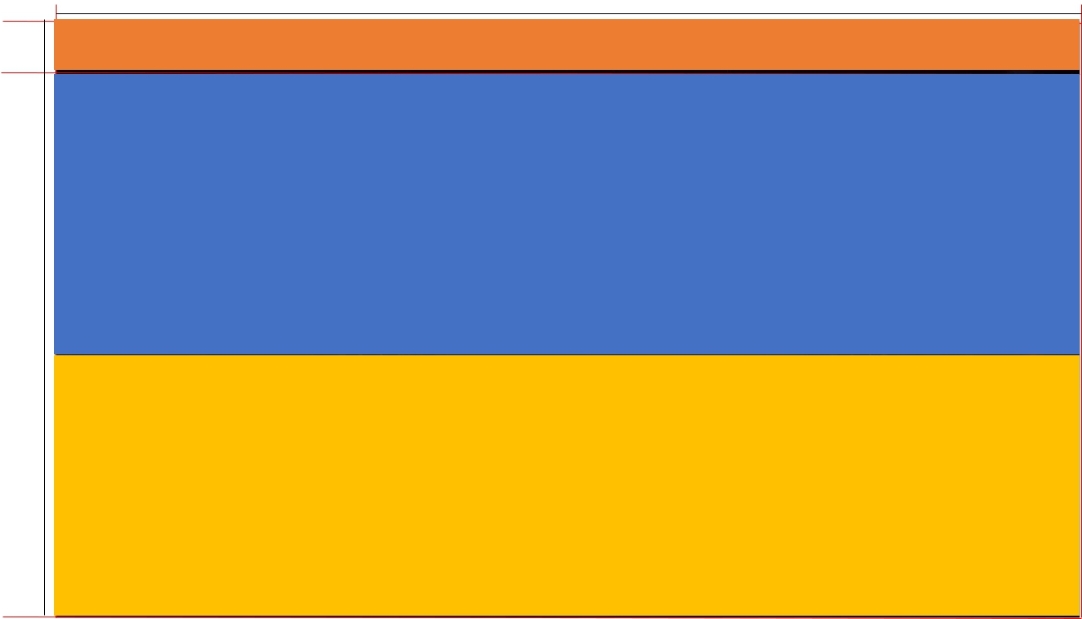

1920

104

1080



Status Bar Area



Widget Area

# COMMON

976



Application

Menu Area

### Font

* + Using Arial
  + Font size unit: px

### Background

|  |  |  |
| --- | --- | --- |
| **No. File Name** | **Size(Pixel)** | **Folder** |
| 1 bg_full.png | 1920 x 1080 | Img/ |

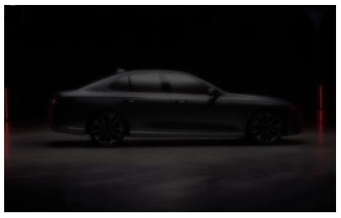

### Button Image

Normal Pressed Focus

|  |  |  |
| --- | --- | --- |
| **State** | **Description** | **Image Source** |
| Normal | When item not selected or pressed by mouse/touch | xxx_n.png |
| Pressed | When item press by mouse/touch | xxx_p.png |
| Focus | When user using keyboard to selected item | xxx_f.png |

## Home Area

2.5

5

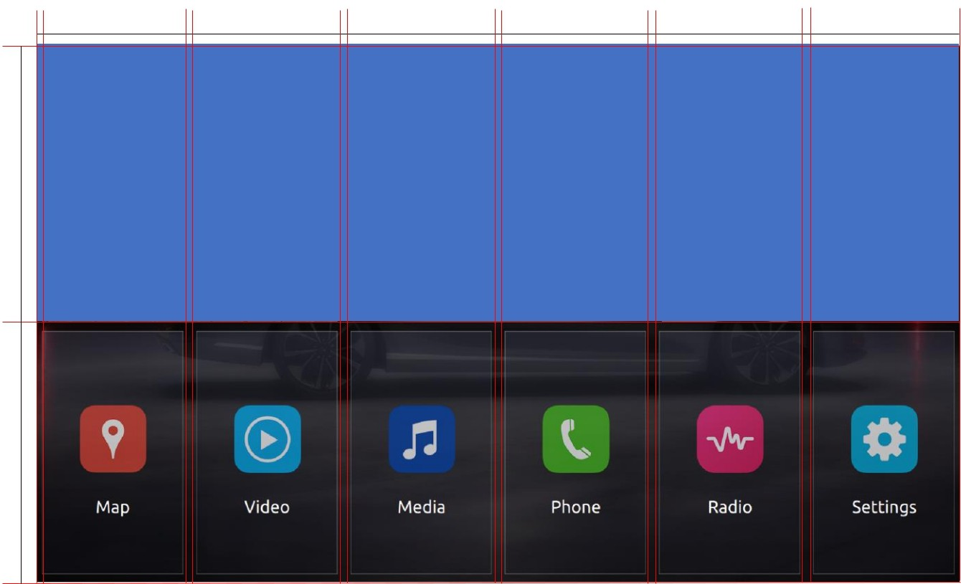316

5

316

5

316

316

5 5

316

316

570

406

#### 2.1. Application Button

316

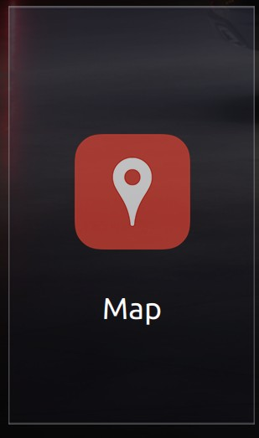

350

1

A

406

|  |  |  |
| --- | --- | --- |
| **No. File Name** | **Size(Pixel)** | **Folder** |
| A btn_home_menu_xxx_n/p/f/  1 | 316x604 | HomeScreen |
|  | | |

|  |  |  |  |  |
| --- | --- | --- | --- | --- |
| **No.** | **Description** | **Font(Pixel)** | **Posistion** | **Color** |
| 1 | Default font | 36 | Horizontal Center Align | #FFFFFF |

158

158

## Widget Area

|  |  |
| --- | --- |
| **No.** | **Description** |
| 1 | Map Widget |
| 2 | Climate Widget |
| 3 | Media Widget |

5

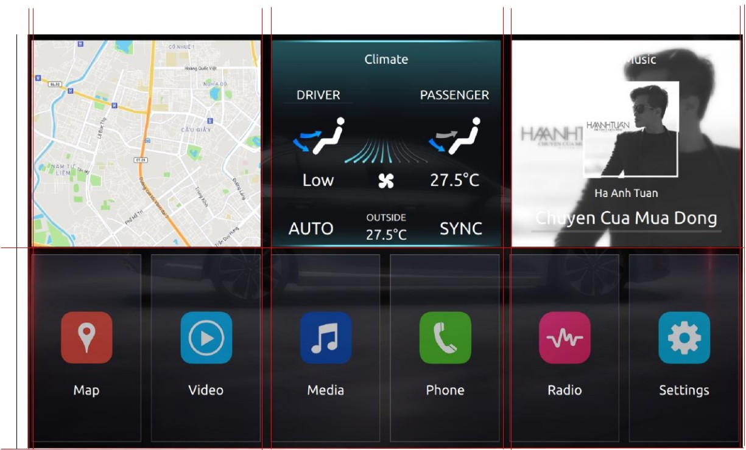

2.5

5

2.5

635 635 635

1

2

3

570

526

2.5

#### Climate Widget

635

|  |  |  |  |  |
| --- | --- | --- | --- | --- |
| **No.** | **Description** | **Font(Pixel)** | **Posistion** | **Color** |
| 1 | Climate | 34 | Horizontal Center Align | #FFFFFF |
| 2 | Driver | 34 | Horizontal Center Align | #FFFFFF |
|  |  |  |  |  |
| 3 | Passenger | 34 | Horizontal Center Align | #FFFFFF |
| 4 | Driver temp | 46 | Horizontal Center Align | #FFFFFF |
|  |  |  |  |  |
| 5 | Passenger temp | 46 | Horizontal Center Align | #FFFFFF |

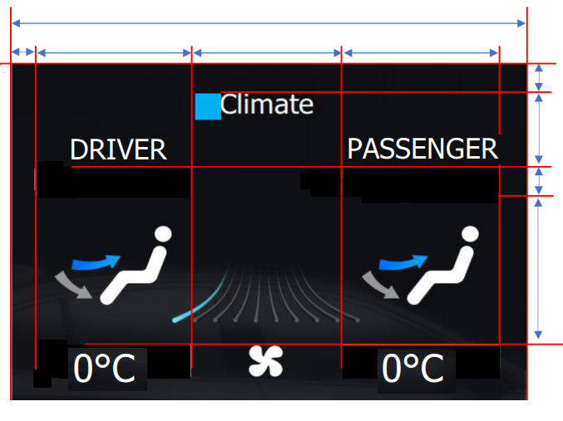

43

5

4

2

3

1

40

179

41

95

184

182

184

|  |  |  |  |  |
| --- | --- | --- | --- | --- |
| 6 | AUTO Mode | 26 | Horizontal Center Align | #FFFFFF |
| 7 | Outside temp | 46 | Horizontal Center Align | #FFFFFF |
| 8 | SYNC Mode | 26 | Horizontal Center Align | #FFFFFF |
|  |  |  |  |  |

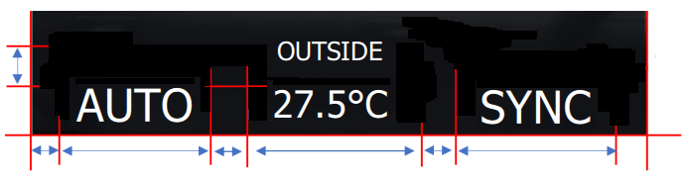

30

172

30

172

30

172

129

8

7

6

39

#### 3.2 Media Widget

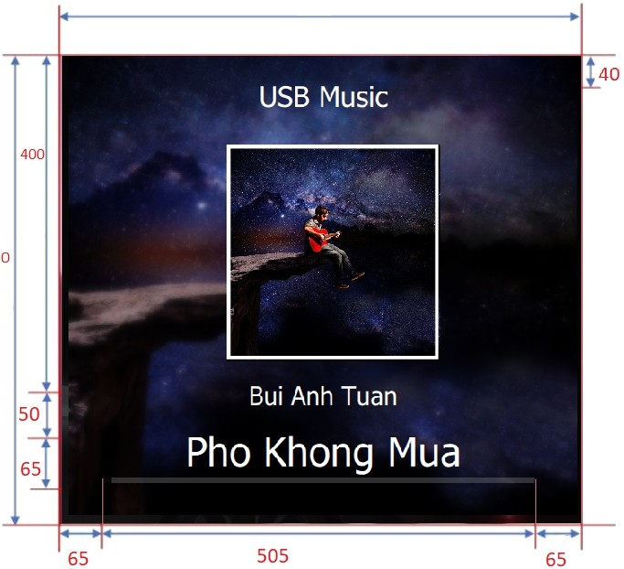

1

570

2

3

635

258

|  |  |  |  |  |
| --- | --- | --- | --- | --- |
| **No.** | **Description** | **Font(Pixel)** | **Posistion** | **Color** |
| 1 | Label: USB Music | 34 | Horizontal Center Align | #FFFFFF |
| 2 | Singer name | 30 | Horizontal Center Align | #FFFFFF |
| 3 | Media title | 48 | Horizontal Center Align | #FFFFFF |

|  |  |  |  |
| --- | --- | --- | --- |
| **No.** | **File name** | **Size(Pixel)** | **Folder** |
| A1 | widget_media_album_bg.png | 34 | Img/Homescreen/ |
| A2 | cover_art.jpg(Large) | 30 | Img/Homescreen/ |
| A3 | cover_art.jpg (Small) | 48 | Img/Homescreen/ |
| A4 | widget_media_pg_s.png | Flexible x 6 | Img/Homescreen/ |

A1

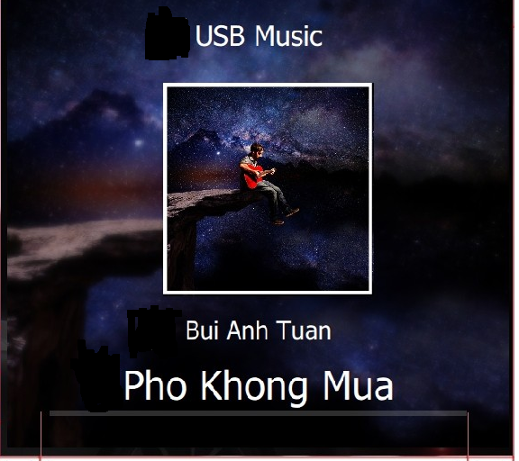

A4

A2

A3



#### 3.3 Widget Button

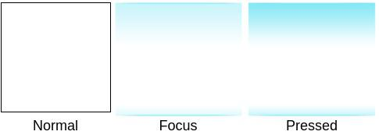

|  |  |  |
| --- | --- | --- |
| **State** | **Description** | **ImageSource** |
| **Normal** | When item not selected or pressed  by  mouse/touch |  |
| **Focus** | When item is focused | xxx_p.png |
| **Pressed** | When item press by mouse/touch | xxx_f.png |

1. Status Bar Area

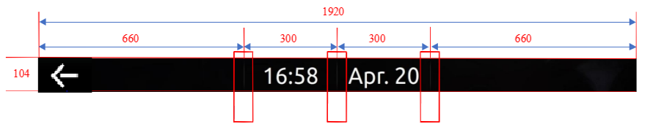

1

1

1

A1

A1

2

|  |  |  |
| --- | --- | --- |
| **No. File Name** | **Size(Pixel)** | **Folder** |
| **1** status_divider.png | 2x104 | StatusBar |
| **2** btn_top_back.png | 134x101 | StatusBar |

|  |  |  |  |  |
| --- | --- | --- | --- | --- |
| **No.** | **Description** | **Font(Pixel)** | **Posistion** | **Color** |
| **A1** | Default font | 72 | Horizontal Center Align | #FFFFFF |

#### 4.1 Back Button

Normal Pressed Focus

|  |  |  |  |
| --- | --- | --- | --- |
| **State** | **Description** | **ImageSource** | **Folder** |
| Normal | When item not selected or pressed  by mouse/touch | xxx_n.png | StatusBar |
| Pressed | When item press by mouse/touch | xxx_p.png | StatusBar |
| Focus | When user using keyboard to selected item | xxx_f.png | StatusBar |

1. Application Layout

1920

|  |  |
| --- | --- |
| **No.** | **Description** |
| 1 | Back Button |
| 2 | Status Bar |
| 3 | Appication Name |

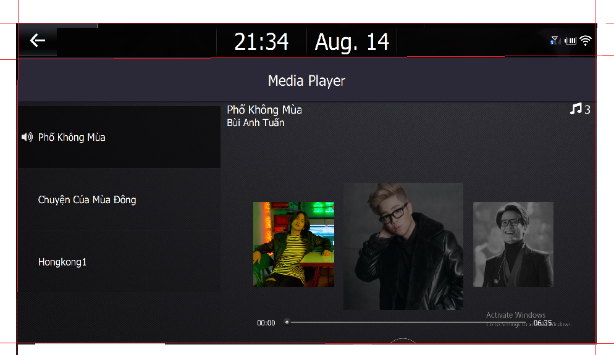

104

141

3

2

1